DNS Opgaver
Run nslookup to obtain the IP address of the web server for the Indian Institute of Technology in Bombay, India: www.iitb.ac.in. What is the IP address of www.iitb.ac.in
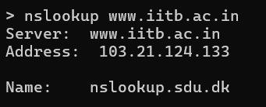
The adress is 103.21.123.133
2. What is the IP address of the DNS server that provided the answer to your nslookup command in question 1 above?
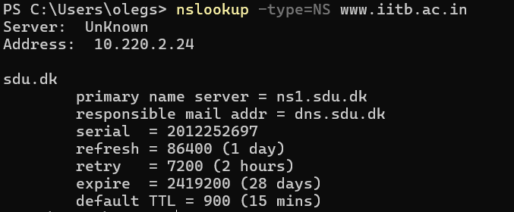
The IP of the local DNS server is 10.220.2.24
3. Did the answer to your nslookup command in question 1 above come from an authoritative or non-authoritative server?
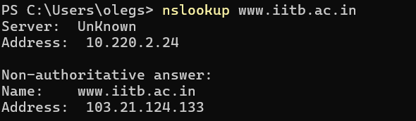
Its a Non-authoritative answer
4. Use the nslookup command to determine the name of the authoritative name server for the iit.ac.in domain. What is that name? (If there are more than one authoritative servers, what is the name of the first authoritative server returned by nslookup)? If you had to find the IP address of that authoritative name server, how would you do so?
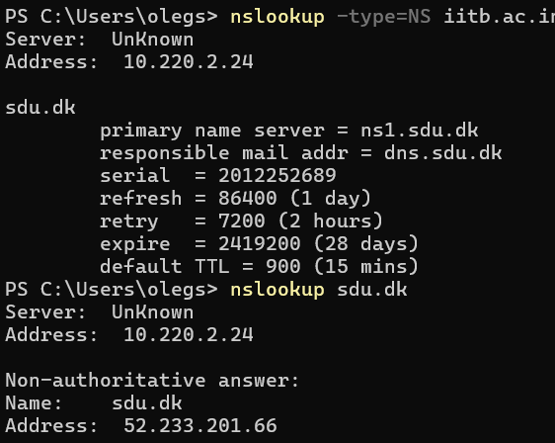
There is only one server called sdu.dk. It has address: 52.233.201.66

The DNS cache on your computer
You can also explicitly clear the records in your DNS cache. There’s no harm in doing so – it will just mean that your computer will need to invoke the distributed DNS service next time it needs to use the DNS name resolution service, since it will find no records in the cache. On a Mac computer, you can enter the following command into a terminal window to clear your DNS resolver cache:
sudo killall -HUP mDNSResponder
On Windows computer you can enter the following command at the command prompt:
ipconfig /flushdns
Tracing DNS with Wireshark
5. Locate the first DNS query message resolving the name gaia.cs.umass.edu. What is the packet number6 in the trace for the DNS query message? Is this query message sent over UDP or TCP?
109 10:35:59,565615 10.126.65.119 10.220.2.24 DNS 77 Standard query 0x2ad3 A gaia.cs.umass.edu
The first DNS query message
6. Now locate the corresponding DNS response to the initial DNS query. What is the packet number in the trace for the DNS response message? Is this response message received via UDP or TCP?
It is received from UDP

7. What is the destination port for the DNS query message? What is the source port of the DNS response message?
Destination Port: 53
Source Port: 60488

8. To what IP address is the DNS query message sent?
Source Address: 10.220.2.24

9. Examine the DNS query message. How many “questions” does this DNS message contain? How many “answers” answers does it contain?
Questions: 1
Answers: 0

10. Examine the DNS response message to the initial query message. How many “questions” does this DNS message contain? How many “answers” answers does it contain?
Questions: 1
Answers: 1

11. The web page for the base file http://gaia.cs.umass.edu/kurose_ross/ references the image object http://gaia.cs.umass.edu/kurose_ross/header_graphic_book_8E_2.jpg, which, like the base webpage, is on gaia.cs.umass.edu. What is the packet number in the trace for the initial HTTP GET request for the base file http://gaia.cs.umass.edu/kurose_ross/?

What is the packet number in the trace of the DNS query made to resolve gaia.cs.umass.edu so that this initial HTTP request can be sent to the gaia.cs.umass.edu IP address?
What is the packet number in the trace of the received DNS response?
What is the packet number in the trace for the HTTP GET request for the image object http://gaia.cs.umass.edu/kurose_ross/header_graphic_book_8E2.jpg?
What is the packet number in the DNS query made to resolve gaia.cs.umass.edu so that this second HTTP request can be sent to the gaia.cs.umass.edu IP address?
Discuss how DNS caching affects the answer to this last question.
If we do not clear the cache, the image will already be loaded to the website, meaning a DNS call will not be called. The DNS helps to retrieve the jpg to the website.

12. What is the destination port for the DNS query message? What is the source port of the DNS response message?

13. To what IP address is the DNS query message sent? Is this the IP address of your default local DNS server?
My local DNS server 10.220.2.24
The DNS gateway is 10.220.2.24
Its the same

14. Examine the DNS query message. What “Type” of DNS query is it? Does the query message contain any “answers”?
The DNS query is UDP and has 1 question and 0 answers
15. Examine the DNS response message to the query message. How many “questions” does this DNS response message contain? How many “answers”?
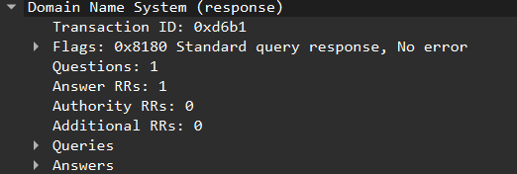
It has 1 question and 1 answer

Last, let’s use nslookup to issue a command that will return a type NS DNS record, Enter the following command:
nslookup –type=NS umass.edu
and then answer the following questions

16. To what IP address is the DNS query message sent? Is this the IP address of your default local DNS server?

My local DNS server 10.126.65.119
The DNS gateway is 10.126.65.119
Its the same

17. Examine the DNS query message. How many questions does the query have? Does the query message contain any “answers”?
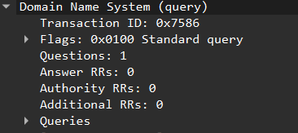
18. Examine the DNS response message. How many answers does the response have? What information is contained in the answers?
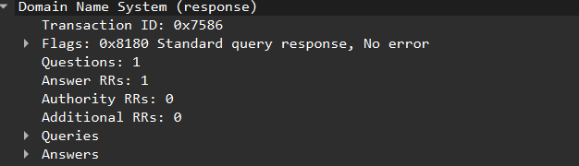
There is no aditional resource records. I only get one answer, because I use Eduroom

